Name : Zid’Avwa Al Bari’i

NIM : 244107020083

Class/Number : TI-2I / 26

Jobsheet 2

# First Code

## Code 1

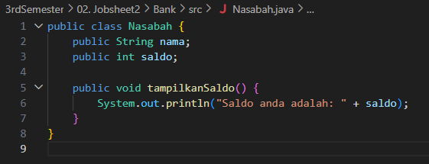 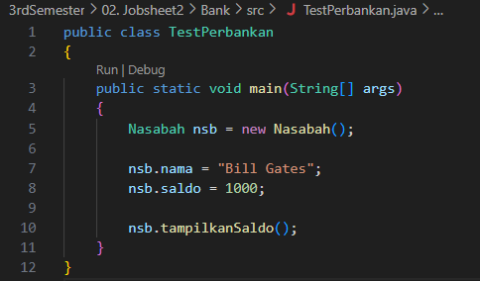

## Output 1



# Second Code

## Code 2

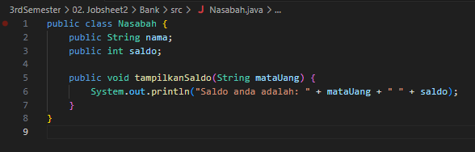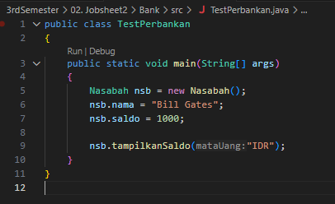

## Output 2



# Third Code

## Code 3

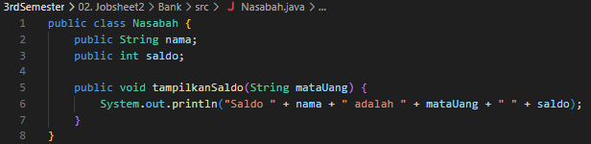 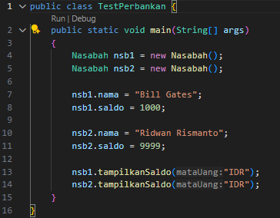

## Output 3

